**HW6 Simulation: Turbine Blade**

**21900793 한태건**

① Change material from aluminum alloy to structural steel. Explain differences in the temperature distribution and maximum stress with values of thermal conductivity(k), thermal expansion coef.(α), and elastic modulus(E).

|  |  |  |
| --- | --- | --- |
|  | Aluminum alloy | Structural steel |
| Temperature  distribution |  |  |
| Maximum stress |  |  |

Table 1. Results of Simulations

|  |  |  |
| --- | --- | --- |
| Material Property | Structural Steel (SS400) | Alluminum Alloy (6061-T6) |
| Thermal expansion coefficient (α) | 1.2 x ${10}^{-5}$ ° $C^{-1}$ | 2.3 x ${10}^{-5}$ ° $C^{-1}$ |
| Thermal conductivity (k) | 60.5 W.m-1. ° $C^{-1}$ | temperature dependent |
| Elastic modulus (E) | 200 GPa | 71 GPa |

Table 2. Material Properties

* **Temperature distribution**

Conduction formal is as follows.

$$\frac{∂q}{∂x}=k\frac{dT}{dx}$$

That is, if Conduction is the same temperature change, it is determined by the thermal conductivity value. Table 2 shows that the thermal conductivity value of Aluminum Alloy is written as 'temperature dependent'. However, at temperatures under the same conditions, it has a larger value than Structural Steel. Therefore, steel has a lower thermal conductivity than aluminum, so the temperature distribution will not be uniform under the same thermal conditions. Because of this, heat conduction is less effective in structural steel compared to aluminum alloy, you can confirm that the minimum temperature is lower for steel at locations farther from the heat source simply by looking at the simulation results in Table 1. In addition, as a result of checking the intermediate temperature through the Probe in the middle, it can be confirmed through simulation that steel does not transfer heat than aluminum.

* **Maximum stress**

The relationship equation between Elastic modulus and thermal expansion coefficient and stress is as follows.

$$σ=E∙α∙∆T$$

Referring to Table 2, the thermal expansion coefficient of aluminum is greater than that of steel. However, the elastic modulus is larger in steel. The stress is greater in steel because the difference in elastic modulus is greater than the difference in thermal expansion coefficient between the two materials. Likewise, this can be confirmed through the simulation results in Table 1. The maximum stress (Von-Mises) of aluminum is 166.16 MPa and the maximum stress (Von-Mises) of steel is 253.68 MPa, which is greater for steel. When the stress was checked through the probe in the middle, it was confirmed that the stress of steel was greater overall.

② Try a transient heat transfer (initial temperature of 22°C) and transient structural analysis. Discuss on the difference between the steady and transient analysis.

|  |  |  |
| --- | --- | --- |
|  | Steady | Transient |
| Outline |  |  |
| Total Deformation |  |  |
| Equivalent Stress |  |  |
| Temperature |  |  |
| Analysis Setting |  |  |

Table 3. Comparison values of Steady and Transient

The steady state assumes that a stable state has been reached without being affected by time. In other words, it focuses on the final stable state. On the other hand, Transient represents how it changes over time by various conditions. In other words, this is not an interpretation based on the fact that it has reached a certain state, but an interpretation method that is greatly influenced by time by the set value. In Table 3, two values, steady and transient, are compared. Transient's result value was different from steady due to the influence of time. In the case of total deformation max, there were almost the same, and difference of the stress max was about 0.04 MPa. On the other hand, the maximum of temperature is the same as the two values. The temperature was the same because the initial temperature distribution did not significantly affect the temperature in the transient analysis.

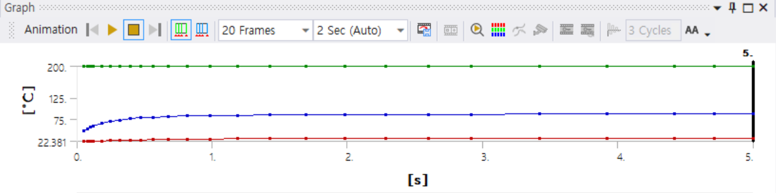

Fig 1. Temperature changing in Transient

This is a temperature change for a transient with a step end time of 5. The blue one is average, the red one is minimum, and the green one is maximum. We can see the temperature changes. Next, this is the stress changes by time in transients.

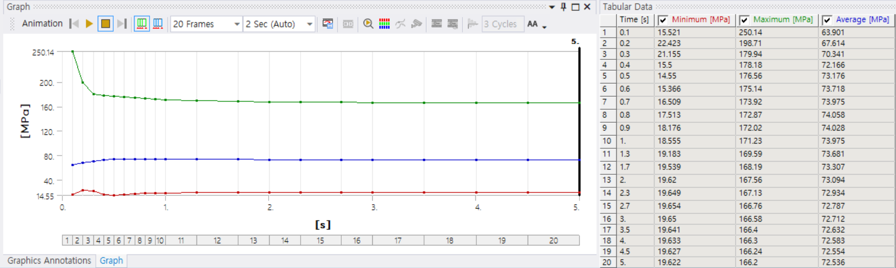

Fig 2. Stress changing in Transient

In Figure 2, it can be seen that the stress change at the beginning of the transient interval changes over time. It can be seen that it converges to any one value as time passes. However, in the steady-state, there is no impact of time, so unlike transients, it remains converged to one value without change.

In conclusion, the transient differs from the Steady value because it is heavily influenced by time.